Smart Waste Classifier – Java Based Waste Segregation Suggestion System
PROJECT REPORT
Project Title: Smart Waste Classifier – Java Based Waste Segregation Suggestion System
Course: Programming in Java — CSE2001
Submitted by: Aatmaja Ghundare
Registration No.: 24BAS 10064
Department: Aerospace Engineering
Faculty Guide: Prof. Priscilla Dinkar Moyya
Academic Year: 2025 - 2026
ACKNOWLEDGEMENT
I express my sincere gratitude to my faculty guide Prof. Priscilla Dinkar Moyya for providing guidance and valuable suggestions throughout this project. I also thank our institution for the opportunity to work on this real-world problem using Java programming concepts.
ABSTRACT
Waste segregation plays a crucial role in effective waste management and environmental protection. However, common citizens often struggle to identify the correct waste category for everyday items.
This project aims to solve this real-world challenge using a simple Java-based Waste Classification System that takes a waste item name as input and suggests the correct disposal bin based on predefined categories. By automating basic decision-making using conditional statements, this project encourages recycling and environmentally responsible behavior.
INTRODUCTION
Improper waste disposal leads to environmental pollution, increased landfill pressure, and health hazards. Most households dispose of recyclable, hazardous, and biomedical waste in the same bin, making segregation difficult later.
This project uses basic Java programming to create a smart suggestion system that categorizes waste items into:
- Wet Waste → Green Bin
- Dry Waste → Blue Bin
- Recyclable Waste → Blue Bin
- Hazardous Waste → Red Bin
- Biomedical Waste → Yellow Bin
This system is interactive and helps users learn proper disposal habits.
PROBLEM DEFINITION
To create a menu-driven Java application that:
✔ Accepts a waste item name from a user
✔ Automatically classifies it into the correct category
✔ Suggests the appropriate disposal bin
✔ Displays waste categories on request
OBJECTIVES
- To reduce improper waste disposal
- To automate classification using Java logical conditions
- To create a user-friendly system to promote environmental responsibility
REQUIREMENT ANALYSIS
Software Requirements
- Java JDK 8 or above
- Command Line / IDE (VS Code, IntelliJ, Eclipse or BlueJ)
- Operating System: Windows / Linux / macOS
Hardware Requirements
- Minimum 4GB RAM
- Any basic PC or laptop
ALGORITHM
- Start the program
- Display menu options
- Take user choice
- If choice = classify:
  - Input waste item string
  - Convert to lowercase
  - Match based on keywords:
    - wet → green bin
    - dry → blue bin
    - recyclable → blue bin
    - hazardous → red bin
    - biomedical → yellow bin
  - Display results
  - Ask if user wants to classify again
- If choice = view categories → display bin rules
- If Exit → Print goodbye message
- Stop program
IMPLEMENTATION
Java code with if-else logic and menu-driven structure is implemented.
Menu
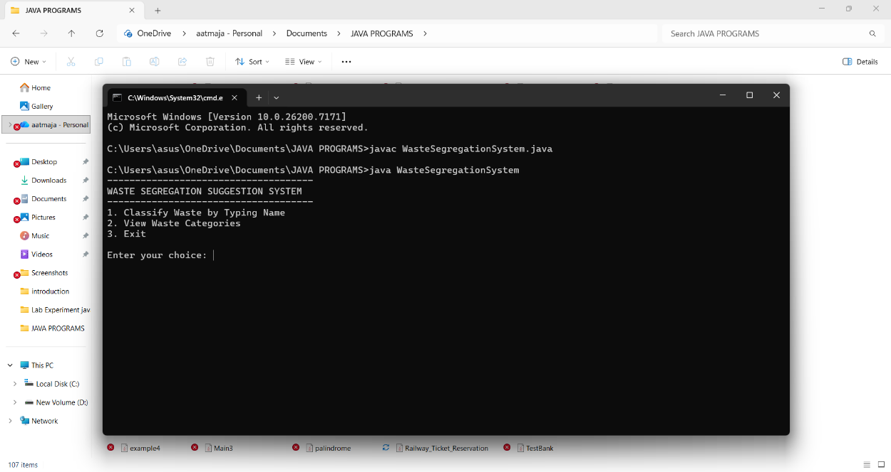

Output:
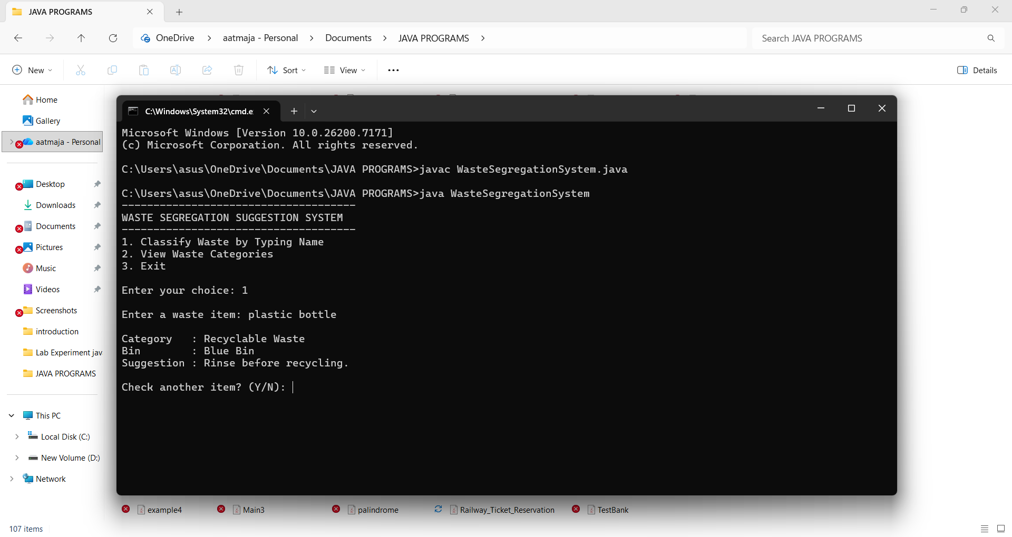

Waste categories:
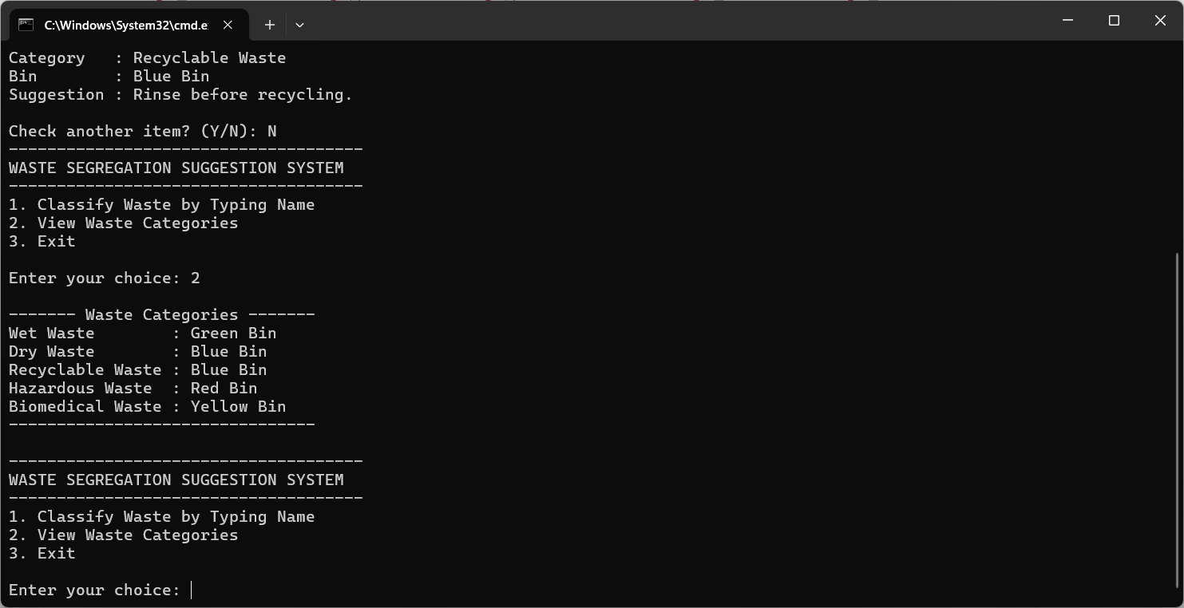
RESULTS & ANALYSIS
The system successfully:
✔ Identifies correct waste category
✔ Suggests disposal bin
✔ Helps users understand segregation
✔ Prevents mixing of harmful waste
CONCLUSION
This project provides a simple yet effective tool to support proper waste segregation using basic Java programming concepts. It spreads awareness and encourages environmental responsibility — making waste disposal smarter and more sustainable.
FUTURE ENHANCEMENTS
- Image & barcode scanning for waste detection
- Mobile app interface
- Cloud database for waste category updates
- Multiple language support
REFERENCES
- Java Documentation – Oracle
- Swachh Bharat Mission Guidelines
- Online tutorials & environmental resources

